If JSR303 fails to pass the verification, use BindingResult to encapsulate the error information and redirect it to the registration page

If it passes the JSR303 verification, it needs to determine whether the verification code is correct from redis. If it is correct, it needs to register with the member service

If the member service invocation succeeds, it is redirected to the login page; otherwise, the error message returned by the encapsulated remote service is returned to the registration page

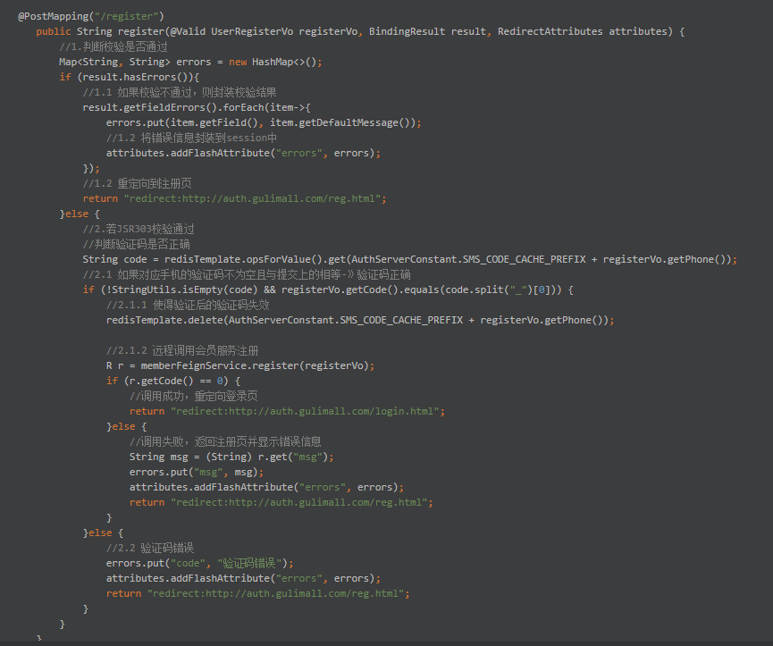

Check whether the current registered member name and phone number are registered through the exception mechanism. If yes, the user will throw a custom exception and encapsulate the error information when returned

If not registered, encapsulate the passed membership information, and set the default membership level, creation time

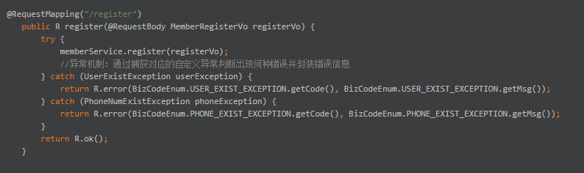

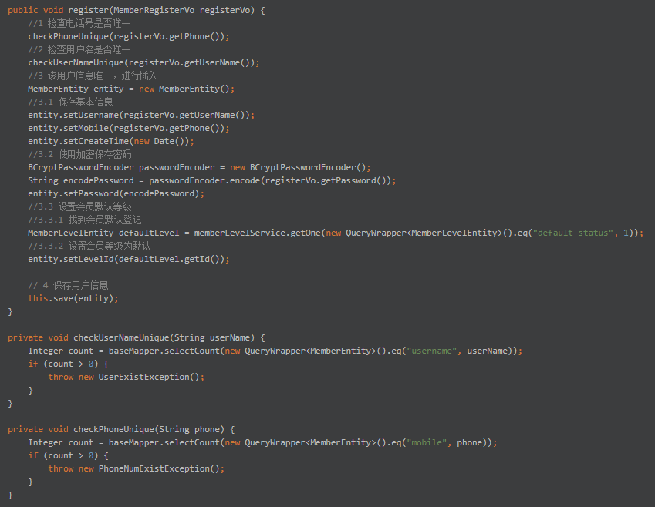

Remotely invoke the login interface through the membership service

If the call succeeds, it is redirected to the home page

If the call fails, the error message is encapsulated and redirected to the login page with the error message

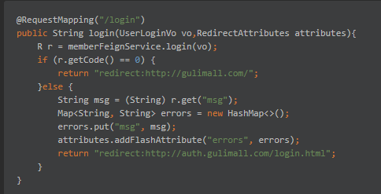

If the database contains a user name or phone number with the current login name and the password matches, the authentication succeeds and the queried entity is returned

Otherwise null is returned and the user name or password error is returned in controller

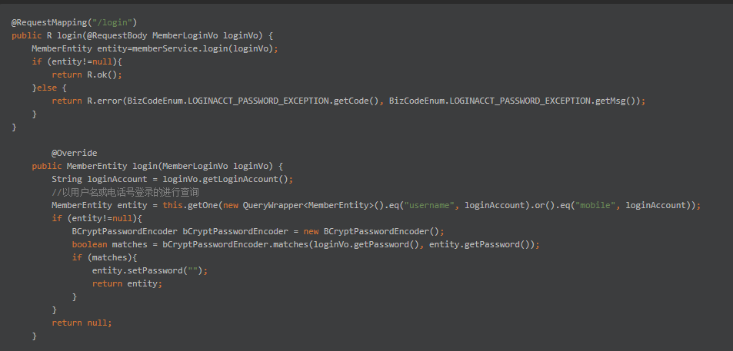

Social login

Send an HttpUtils request to obtain the token and hand the information such as the token to the Member service for social login

If the token fails to be obtained or the service fails to be remotely invoked, encapsulate the error information and return to the login page

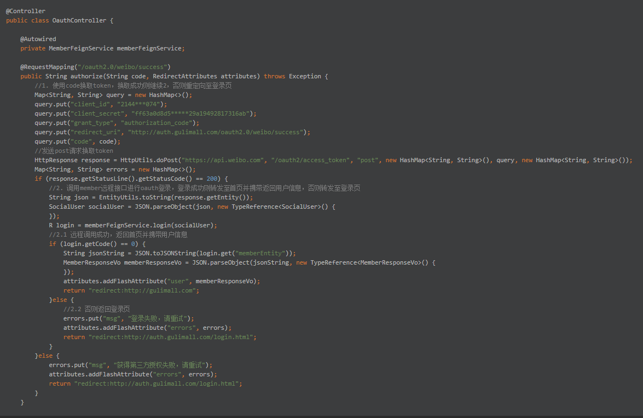

Login interface

There are two processes involved in login, which actually include registration and login

If you have not logged in using the social account before, you can use the token to invoke the open API to obtain the information about the social account, register and return the result

If you have previously logged in using that social account, update the token and return the result

